CHAPTER 8: Forces, energy and motion

Worksheet 8.4

Inertia and motion
Answers
1. State Newton’s First Law of Motion.
A body at rest will remain at rest and a body in motion will not change its speed or direction unless acted upon by an unbalanced force.

2. Consider the following examples of forces acting on a body. In each case find the net (unbalanced) force and describe the resulting motion of the object. Assume north is up the page.
(a)
The body will move to the left as the net force is 20 − 10 = 10 N to the left (i.e. west).
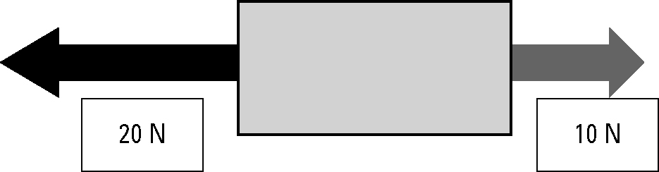
(b)
The body will move at 45° to the right of north (i.e. north-east). The net horizontal force is 7 − 2 = 5 N to the right (east). The net vertical force is 15 − 10 = 5 N up the page (north). The net result of these two equal forces is motion towards the north-east.
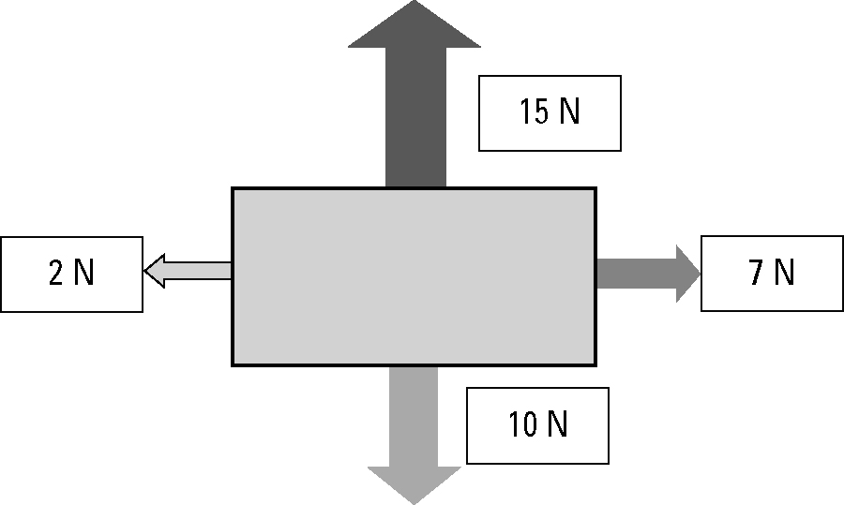
3. A 500-kg box is placed on the tray of a utility truck but it is not secured by ropes. The ute drives along a highway, then the driver has to brake suddenly to avoid a wombat on the road. Use the concept of inertia to explain the danger to the driver.
Inertia is a measure of a body’s resistance to a change in motion. The unsecured box is travelling with the same speed as the ute. When the ute suddenly brakes, the inertia of the heavy box will result in it continuing to move forward into the cabin of the ute. This could cause severe injury or death to the driver.

4. A 1-kg pendulum is mounted on the roof of a vehicle as shown in the diagram.
 | 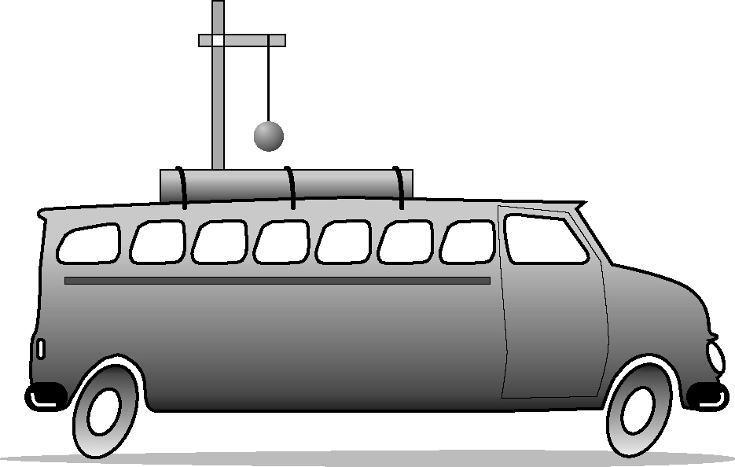 | Describe the motion of the pendulum in each example.  (a) The vehicle accelerates from rest.  The bob will hang backwards towards the rear of the vehicle.  (b) The vehicle brakes from a speed of  60 km/h.  The bob will hang forward towards the front of the vehicle.

